SESSION 1 — ACTIVITY (20 MIN) • STUDENT HANDOUT (Set 1 of 40 — every set uses different data) Decode the Chart
Name: A. LOKESH KUMAR Roll No: 192524157
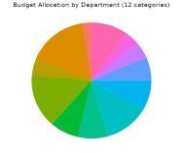
For each chart below, answer: What is it trying to tell you? Do you trust it? Why or why not? 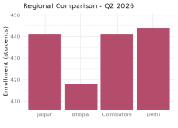
Chart 1
Chart 2
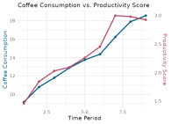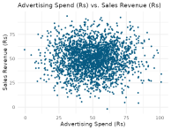^{Chart 3}Chart 4

Your notes:
